附件2：采购设备请单
品牌 | 图片 | 型号 | 数量
格力空调 | 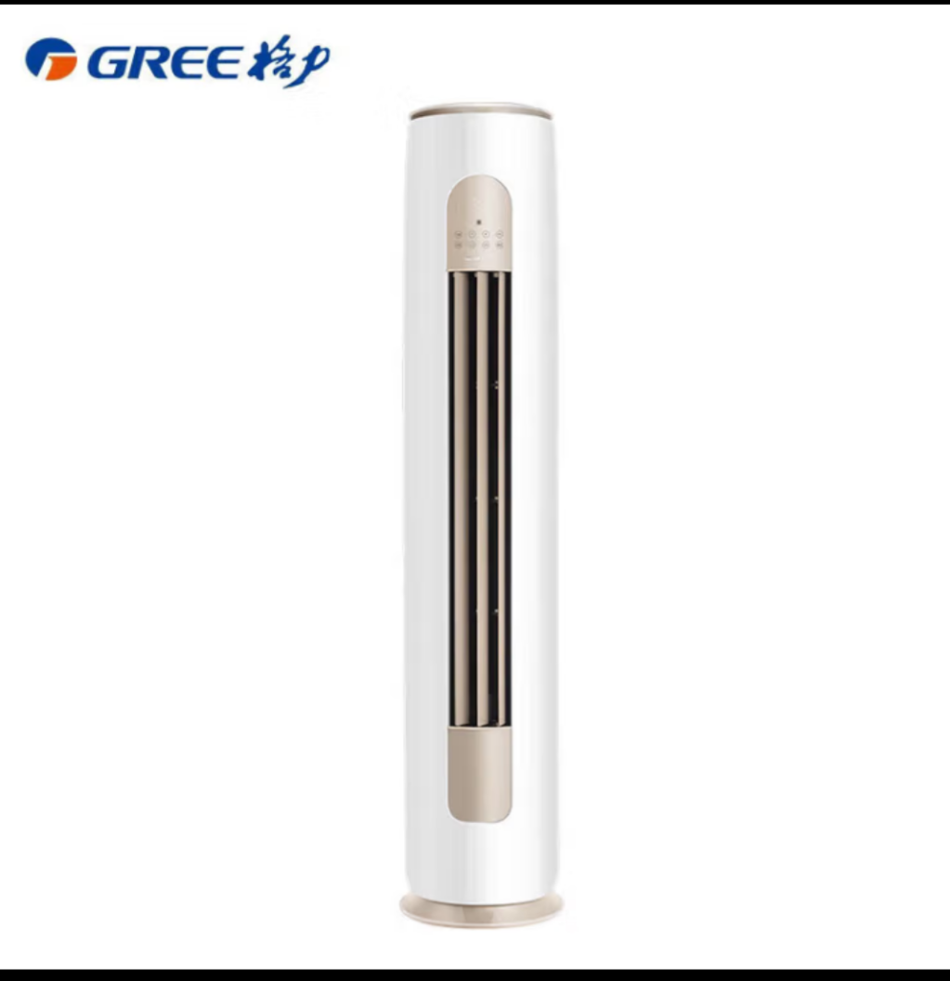 | KFR-72LW/FNHAa-B1 3匹一级能效 | 2
格力空调 | 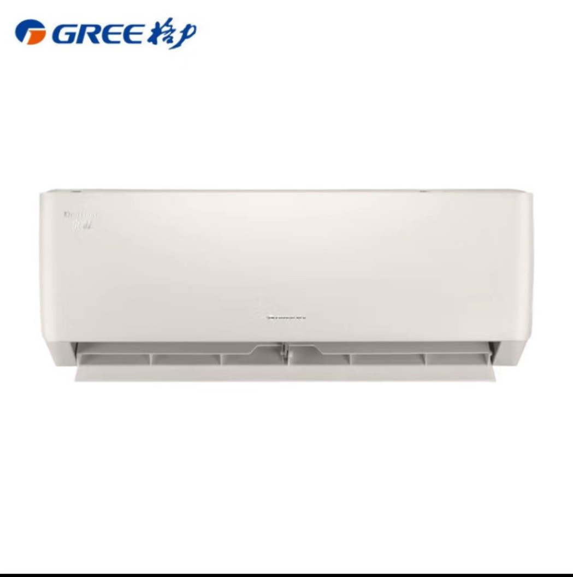 | 格力KFR-35GW/FNhA-B1 | 1

